Use-Case Realization Report
Delete Survey

Issue <1.0>
Revision History
Date | Issue | Description | Author
<dd/mmm/yy> | <x.x> | <details> | <name>

Table of Contents
1. Brief Description 4
2. Flow of Events 4
3. Interaction Diagrams 4
3.1 Collaboration Diagram for Delete Survey 4
3.2 Sequence Diagram for Delete Survey 5
4. Participating Objects 7
5. Class Diagrams 7
5.1 Class Diagram for Delete Survey 7
6. Derived Requirements 7

Use-Case Realization Report
Delete Survey

Brief Description

Flow of Events
[enter the flow of events here; you can use subsections to structure the text]

Interaction Diagrams

Collaboration Diagram for Delete Survey
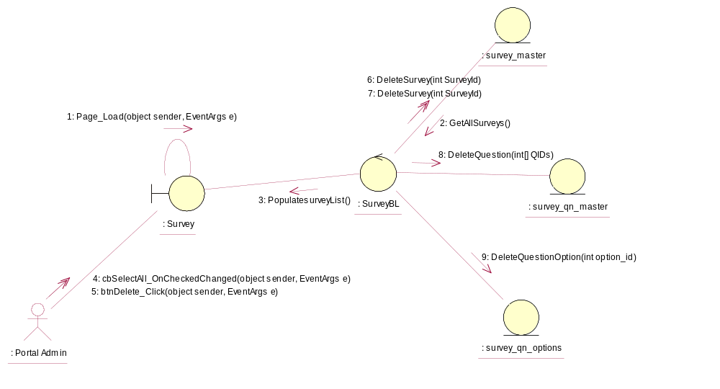

Sequence Diagram for Delete Survey
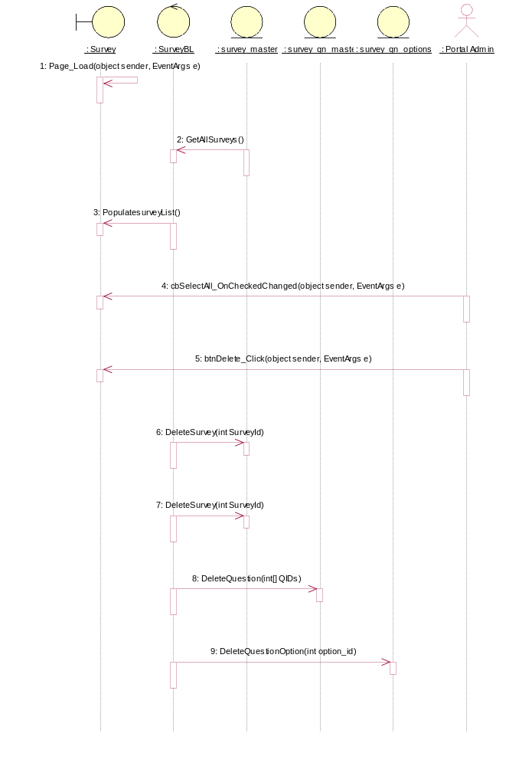

Participating Objects
: Portal Admin

: Survey

: survey_master

: survey_qn_master

: survey_qn_options

: SurveyBL

Class Diagrams

Class Diagram for Delete Survey
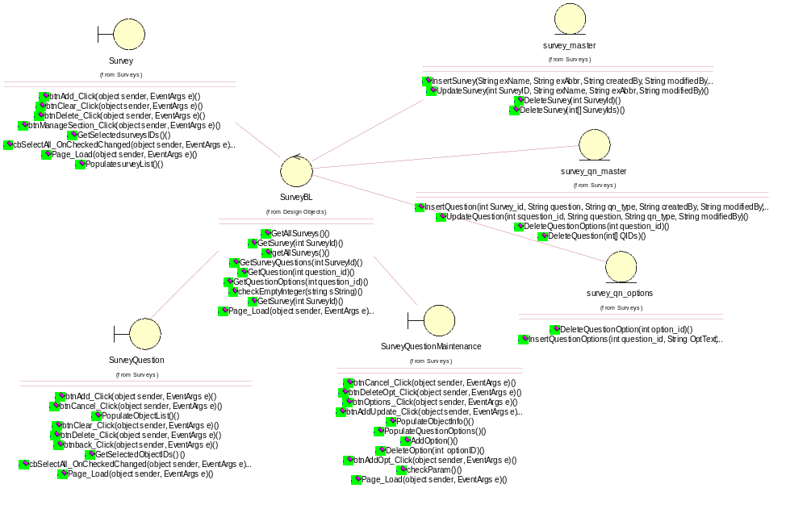

Derived Requirements
[enter the derived requirements here]

